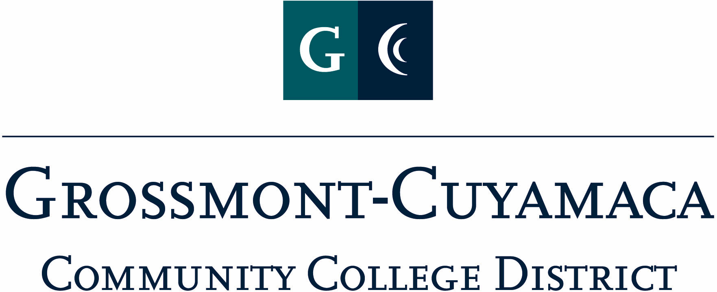
CLASSIFIED SENATE
EXECUTIVE BOARD MEETING
November 2, 2010– Meeting Minutes

Members Present: Debi Miller, Paula Tillery, Maggie Gonzales, Patricia Bailey, Avelina Mitchell, Kimberly Gioscia, Wendy Corbin, Yvette Macy, Maria Briney, Pat Murray, Karen McCoy, Joe Balistreri, Rocky Rose
Members Absent: Scott Howell
Members Excused: Lynne Davidson, Monica Farris, Angela Johnson, JaQ Osborne, Jean Wallace

1. Welcome and Call to Order
The meeting was called to order at 12:03p.

2. Approval of Minutes from
The minutes from October 5, 2010 meeting were approved as amended. M/S/A Rose/Wilder w/2 abstentions.

3. Communication
VP Reports

District: Wendy Corbin reported that the district is going through their restructuring move. The classified representatives reported back that at the Planning & Budget Jam Council they were given information and there was no sharing of input from the constituency groups. The information that was shared at the meeting was passed on to the Chancellor.

Yvette Macy reported on the Mother Goose Parade. She spoke to Deidre Luis, honor society at Grossmont College, and they are orchestrating the chants/cheers for each judge area. The next meeting for the parade will be held on Saturday, 11/20 in Parking Lot #4 at the District. She encouraged those who were walking or part of the float to wear blue or green t-shirts. There will also be a student government banner for the student float. Rocky Rose suggested that those walking in the parade have a school district or college t-shirt to wear. Paula Tillery will check to see if there are any GCCCD t-shirts left. The President asked Y. Macy to find out who did not have a t-shirt, and if affordable, the Senate would pay for them.

Grossmont: At the recent Leadership Meeting with the Chancellor she discussed the scholarship opportunity for classified to attend the upcoming Classified Leadership Institute. She might consider supporting an additional attendant, so there would be 1 from each site. They also discussed developing a leadership program for classified to include public speaking, committee chairing, and to be able to hold a meeting without holding rank in the room. P. Murray is concerned that administration is not connecting “participation” with the “accreditation standards”. Faculty and administrators need to understand that classified are there for accreditation requirements and truly can make valuable contributions if given proper opportunity.

She also reported that the 1st Kudos were delivered, and they are working on the 2nd 8 week distributions. Dr. Cooke, President of Grossmont College, will be organizing a task force to look at professional development activities on campus to include utilizing the CATL program.
Cuyamaca: Maggie Gonzales reported that she had received official entrance into the Academic Planning & Institutional Effectiveness (AP&IE) Task Force.

She attended the Innovation & Planning Retreat and discussed the difference between shared governance and collegial consultation. The college is also forming a task force to look at academic planning and have included classified voice to the group. She has volunteered to be a representative on the college Professional Development Committee so she can tie the District-wide Classified Staff Development Committee activities to the site level.

President’s Report: Debi Miller reported the following:

Open Membership Mtg Flyer: The group had an opportunity to review and are okay with sending out to all classified. She added that the agenda for the meeting will include brainstorming on the CSAD Theme and Committee task organization.

CLI Flyer – Letter of Intent: The group was given an opportunity to review the flyer and are okay with sending out. At the December meeting a Review Committee will be established.

Proclamation for Jan: She will send out once again to the group for their input and okay to move forward.

Card Signing Process: She will send out an e-mail to let her know who will NOT be in attendance at the Holiday Card Signing Party. As discussed from last year’s debrief meeting, the cards will be forwarded to those who are unable to attend to sign ahead of time.

Classified Staff Development Committee: The representatives, Pat Murray, Wendy Corbin, Maggie Gonzales, Jan Recktenwald and Debi Miller, met with Employee & Labor Relations rep (Yvonne Reid-Hairston) to start a dialogue about how to proceed with staff development activities for classified.

Treasurer Report: Paula Tillery reported that funds available in the Senate Trust Account is $4,476.

4. Continuing Business:

Holiday Card: Will include the “Elf” theme.

CSAD: The President called on the Committees for updates. An update from the Raffle/Donation Committee was the only update brought forward. A suggestion was to include CSEA Fundraiser Marie Calendar Pie certificates as one of the raffle prizes. The President will work with the Treasurer on releasing funds for 4 certificates.

Banner Update: Three Classified Senate banners have been ordered and should be delivered by next week.

5. Fundraising Activities:

Dudley Bread: Please refer to the Master Planning Grid for the timeline for this fundraiser.
See’s Candy: Please refer to the Master Planning Grid for the timeline for this fundraiser.
BBQ: Yvette Macy reported on the BBQ fundraiser. She checked with Salam in Financial Aid at Grossmont College to find out what their total expense was for their fundraiser. He indicated that they spent $500 and made $1,000 profit. They sold raffle tickets for donated prizes. The group discussed and brought into play that the way the Classified Senate is organized, we can ask for money for a raffle or a 50/50 drawing. We could offer raffle prizes at the BBQ Fundraiser, but just for random winner with no money attached. We could still do the BBQ and ask a certain price for food served. Y. Macy will continue to research and bring back to the next meeting.

6. Governance:

7. New Business:

CSEA Conference: Yvette Macy reported back to the group about her experience at the conference in August. There were four representatives from our Chapter. It was a great experience and it was hard work. She shared some of the resolutions that were considered.

The meeting adjourned at 12:55p.

